**STAT 40001/MA 59800 Statistical Computing Fall 2017**

**Lab-8**

1. All registered elevators in New York City are provided in the link below <https://www.kaggle.com/new-york-city/nyc-elevators/discussion/39528>

For your convenience the data are attached with this Lab-8

1. Import the data in R.  
   > data = read.csv("C:\\Users\\wu1114\\Desktop\\nyc-elevators.csv")
2. Not all elevators are active. How many are currently active?  
   > attach(data)

> data1 = subset(data,Device.Status=="A")  
> dim(data1)

[1] 66885 29

1. How many elevators are active in Manhattan borough?

> data1 = subset(data,Device.Status=="A"&Borough=="Manhattan")  
> dim(data1)

[1] 39379 29

1. Generate 500 random numbers from a standard normal distribution and display them using a histogram.  
   > x = rnorm(500)  
   > hist(x,col=1:10,xlim = c(-5,5),main='Normal Distribution')  
   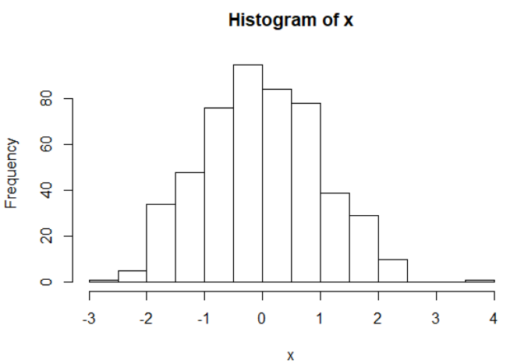
2. Plot pdf of a standard normal distribution by generating data in (-4, 4).

> curve(dnorm(x),-4,4)

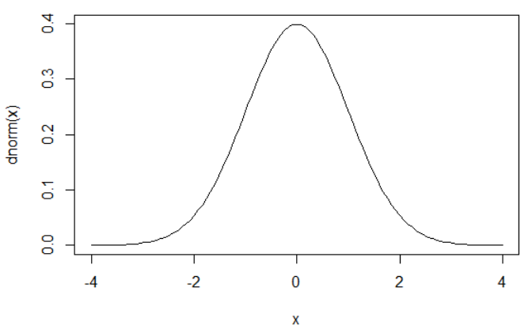

1. Generate 100 random numbers from a normal distribution with mean 5 and variance 64.

> rnorm(100,5,8)

1. Generate 100 random sample form each of the following distribution and draw their normal qq plots
2. Normal

N = rnorm(100)  
> qqnorm(N)  
> abline(0,1)

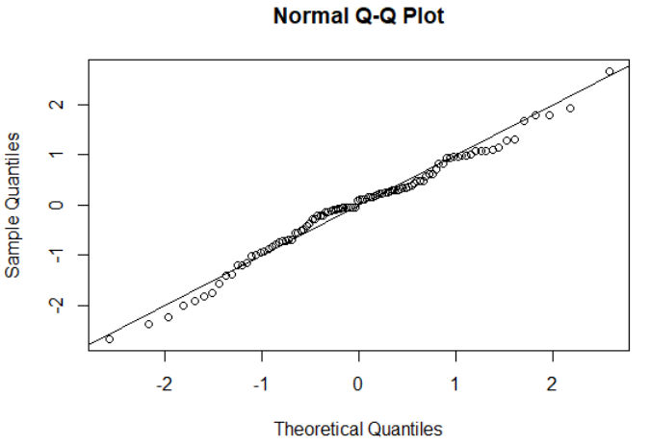

1. Student’s t (use degree of freedom 20)  
   > T = rt(100,5)  
   > qqnorm(T)

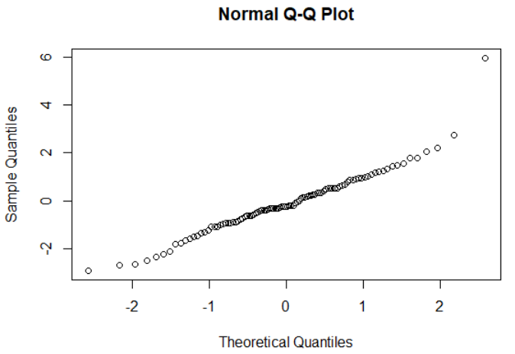

1. Exponential( Use rate=1)

> E = rexp(100,1)

> qqnorm(E)

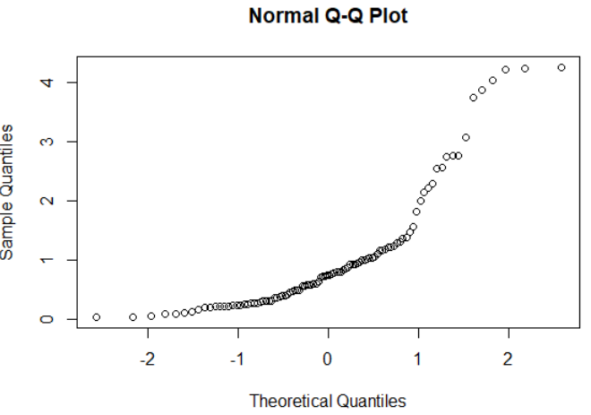

1. Uniform

> U = runif(100)

> qqnorm(U)  
